Pleasant Union Year Round Elementary School

2017-18 School Grading Plan

In the Wake County Public School System, we are committed to maintaining rigorous performance and achievement standards for all students and to providing a fair and consistent process for evaluating and reporting student progress that is understandable to students and their parents and relevant for instructional purposes.

The information below shares specific information about grading at our school

Homework

The following are school-wide expectations for homework:

Homework should be meaningful. It should enrich and extend school experiences, reinforce learning by providing practice and application, and stimulate effort, independence, responsibility, and self-direction. Grade level teachers and resource teachers should plan cooperatively to prevent overlapping of assignments and to consider the needs and abilities of individual students. Grade levels will determine the types of assignments. Teachers should be mindful of special PTA or school-wide evening events when assigning homework. Recommended time parameters for daily assignments will differ by grade level and should not exceed the following:

Kindergarten 20 minutes Grade 3 50 minutes
Grade 1 20 minutes Grade 4 50 minutes
Grade 2 20 minutes Grade 5 50 minutes

The following are grade/subject specific expectations for the completion and grading of homework:
- Each teacher should follow the WCPSS guidelines concerning the amount of homework assigned and the length of time required for completion.
- The teacher will introduce a concept or skill, thoroughly explain the concept or skill, and provide guided practice before making a related homework assignment.
- Homework assignments should be specific, within the student’s ability and have clearly defined expectations. Questions related to the completion of a homework assignment should be answered and clarified.
- Homework assignments are not to be graded but considered practice and considered in reporting a student’s work habit grade.
- Homework should not be given as busy work or as punishment.
- Homework should not be assigned on weekends or track out.
- Examples of homework:
  - Meaningful Reading – If we want students to be life-long readers and enjoy reading, we should engage them in independent reading activities that expose them to a variety of genres. Assessment does not have to always include written reflections, but can instead include a variety of oral activities in book clubs or during guided reading lessons.
  - Reflective Writing Activity – Students can use their written communication skills to reflect on their learning in a journal which teachers check once a week.
- When planning homework ask yourself these questions:
  - How long will it take to complete this assignment?
  - What is the purpose of this homework assignment?
  - What will the student’s attitudes be about the learning after completing this assignment?
  - Can I give immediate feedback on this assignment?
  - Will the homework results give me a picture of what the student can and cannot do?

The school’s Homework Plan can be found in the School Improvement Plan Notebook in the front office. Each teacher also has a copy.

Classwork & Assessments

The following are school-wide expectations for classwork and assessments:
- Classwork should be aligned to the curriculum standards and is meaningful practice that prepares students for common assessments.
- PLTs create common assessments on essential standards. Data from these assessments are recorded on PLT data walls and analyzed.
- Learning targets are provided to students to hold them accountable for what they are learning.

Missed Work

The following are school-wide expectations for missed work:
- Students will be expected to make up missed work.
- Teachers will communicate with the students and parents about the missed assignments that need to be completed.
- Make-up work must be completed within a reasonable amount of time after the absence.

Prevention-Intervention Plan
For students at risk of academic failure, our school seeks to provide a prevention/intervention system that promotes successful completion and mastery of work. Details of our plan are included on our SIP Intervention Matrix.

The following are school-wide expectations for how we support prevention-intervention efforts:

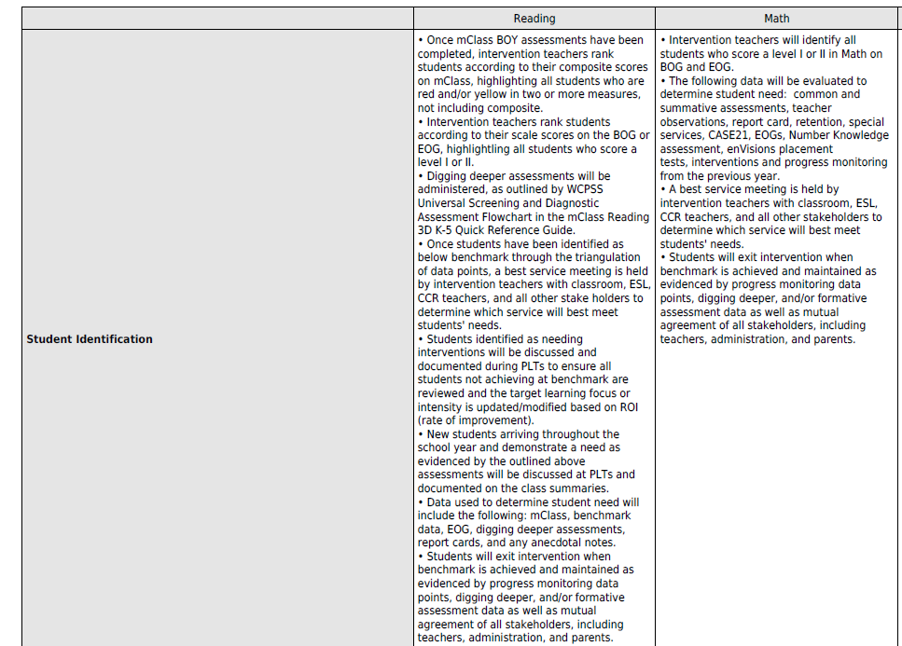

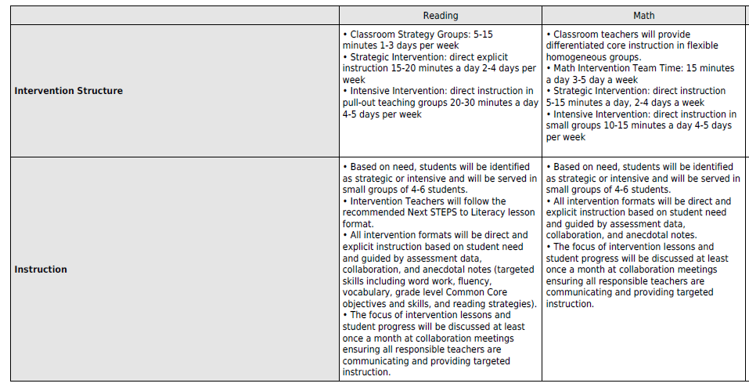

Extra Credit

